There should be a repository with this code somewhere but for the life of me I cant find it

<https://www.youtube.com/watch?v=MAON3E4n_zs>

<https://www.youtube.com/watch?v=Sig-r9ThuhE>

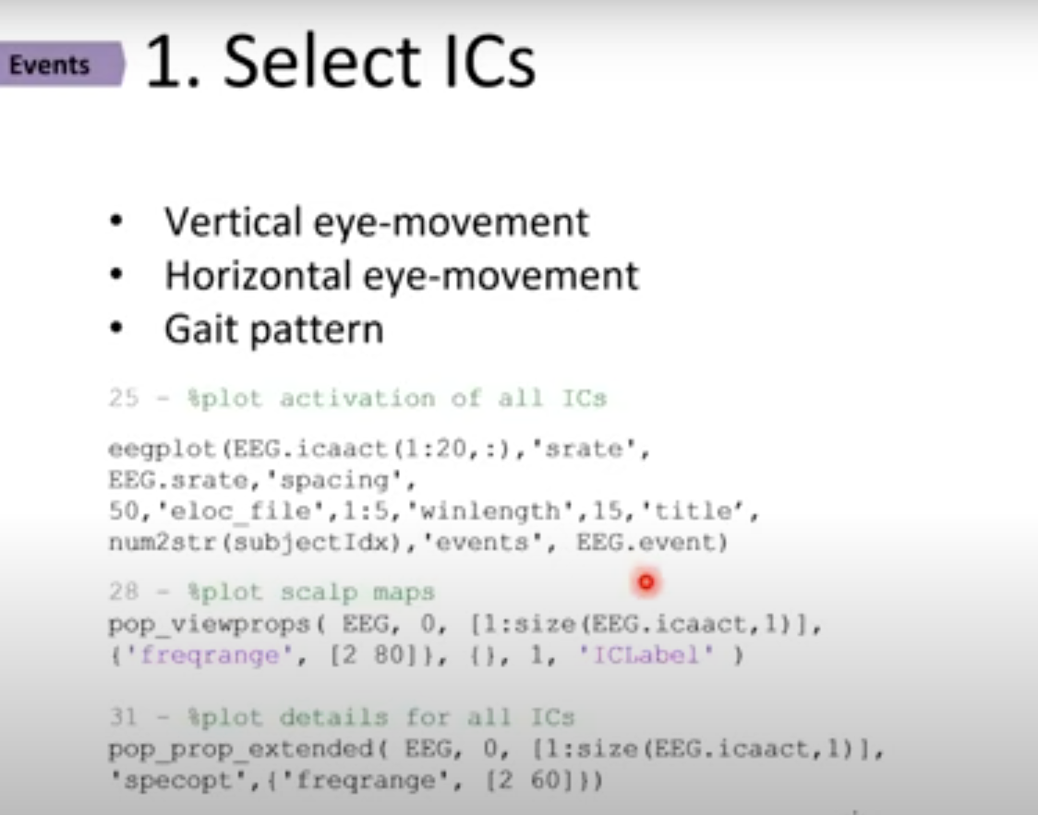

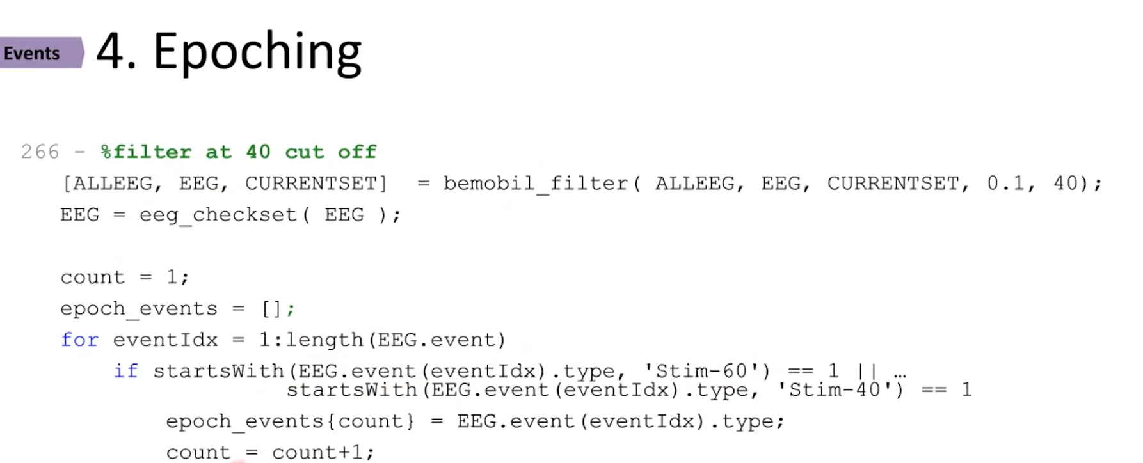

<https://www.youtube.com/watch?v=MAON3E4n_zs>

<https://www.youtube.com/watch?v=Sig-r9ThuhE>